Assignment:
Practice the Code Reviewer Agent, Langflow API, and Input Schema.
Langflow:
Output – Write to file txt format
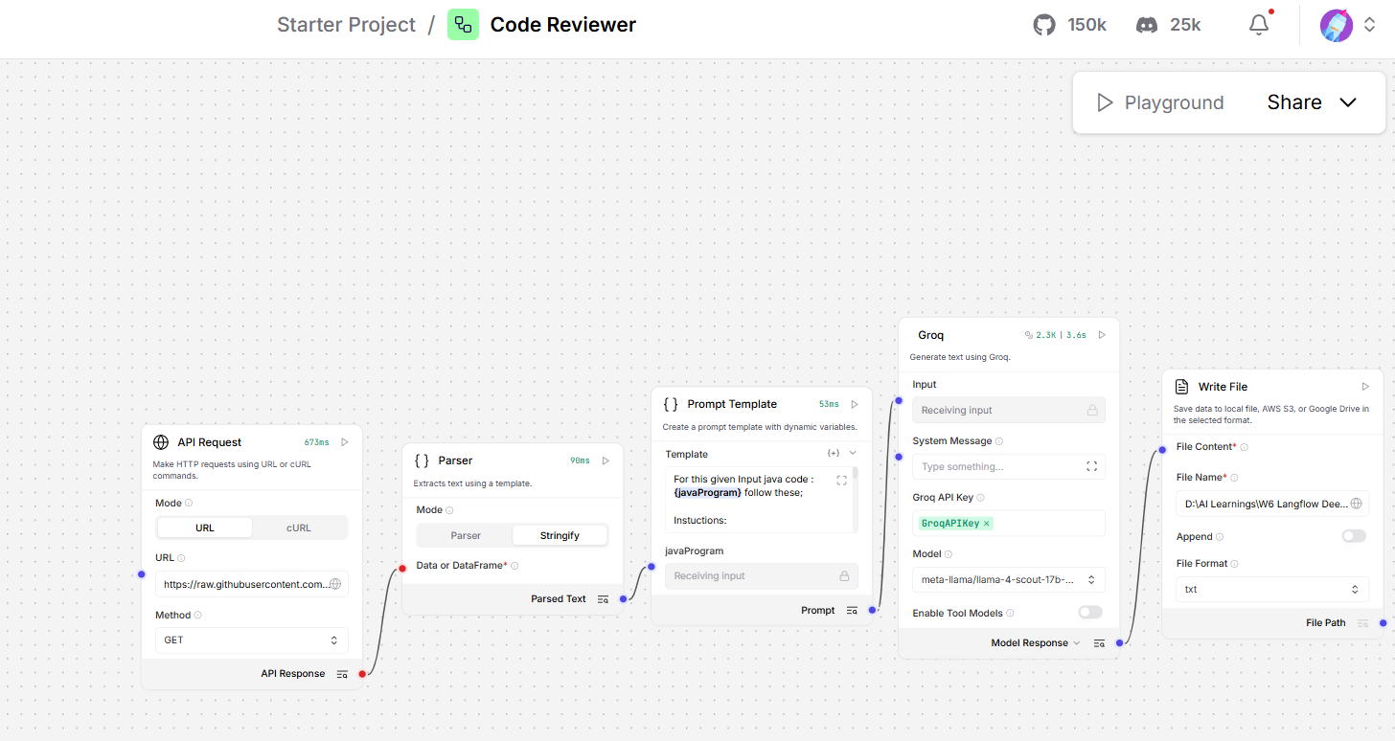

API URL
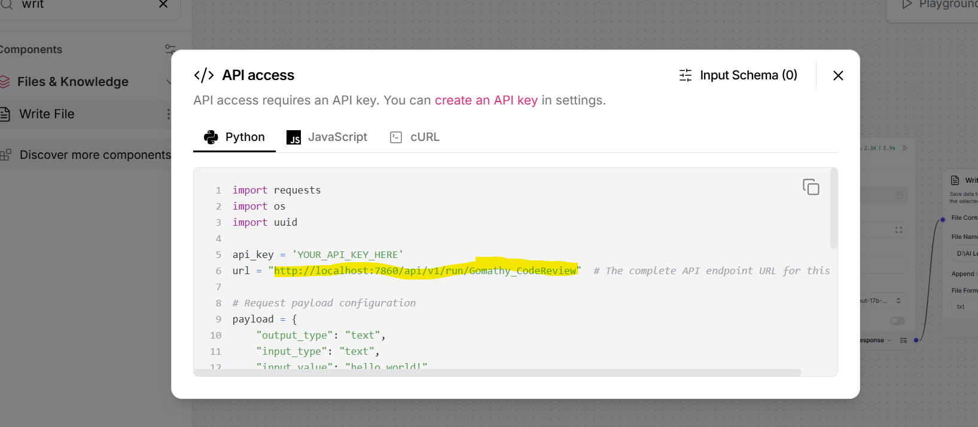
Langflow API Keys:
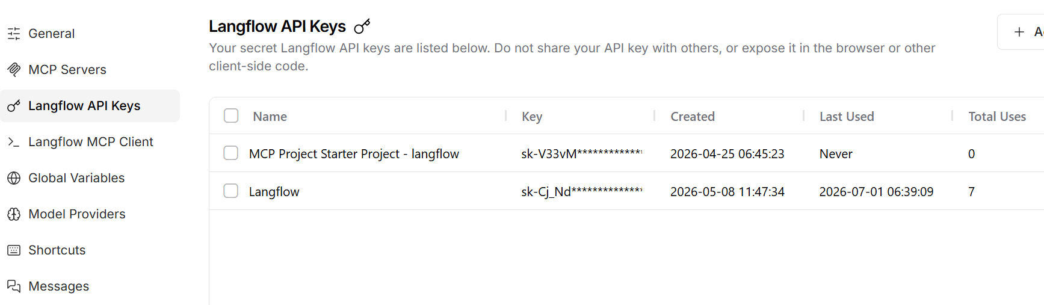

Configure the same in postman
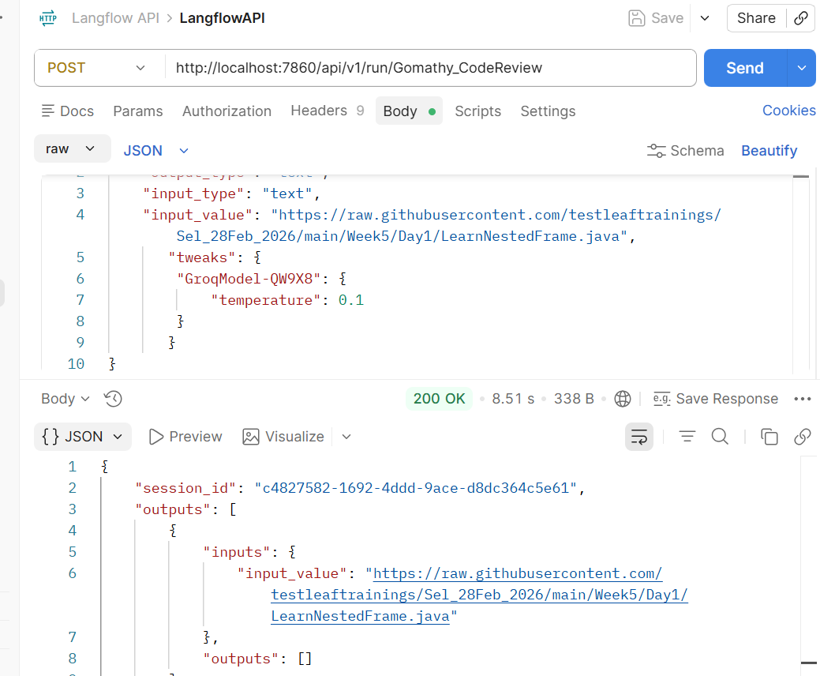

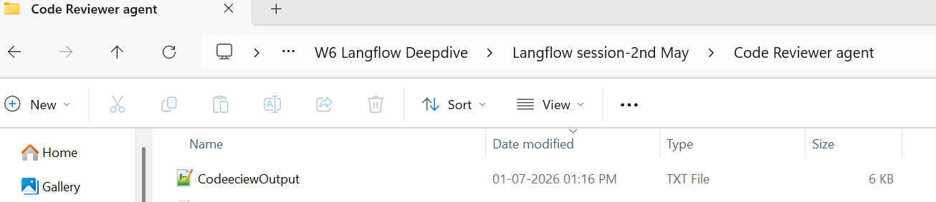

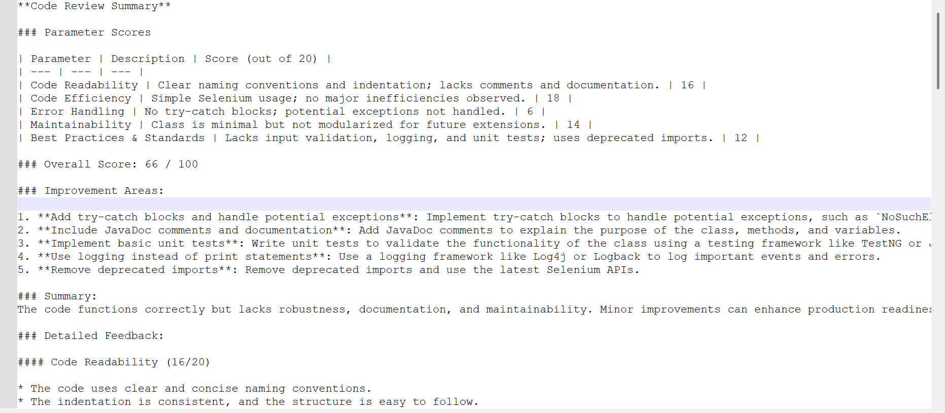

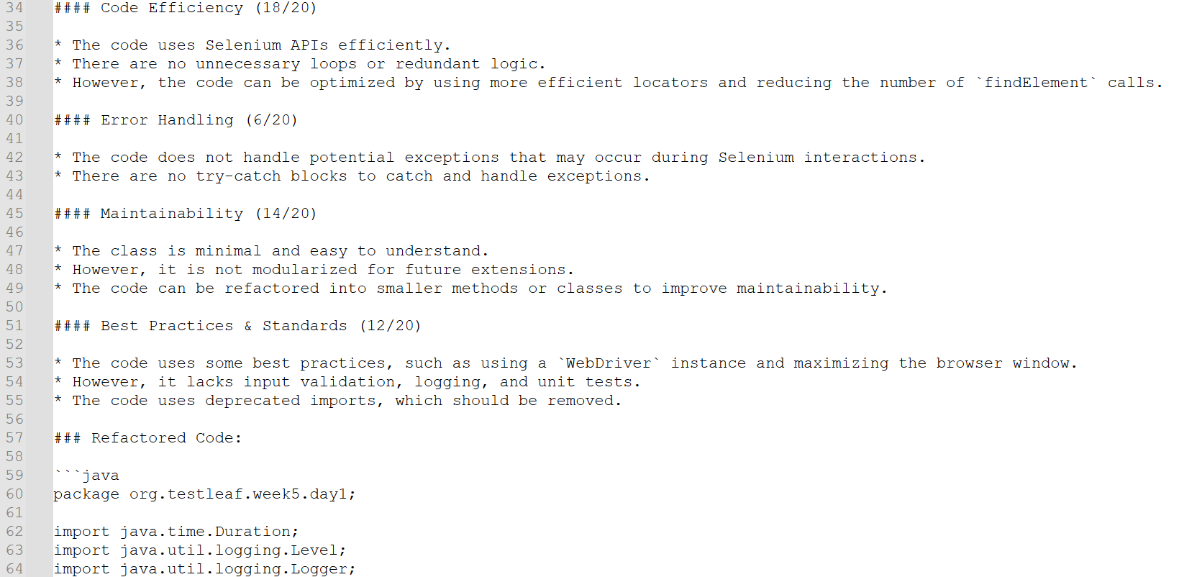

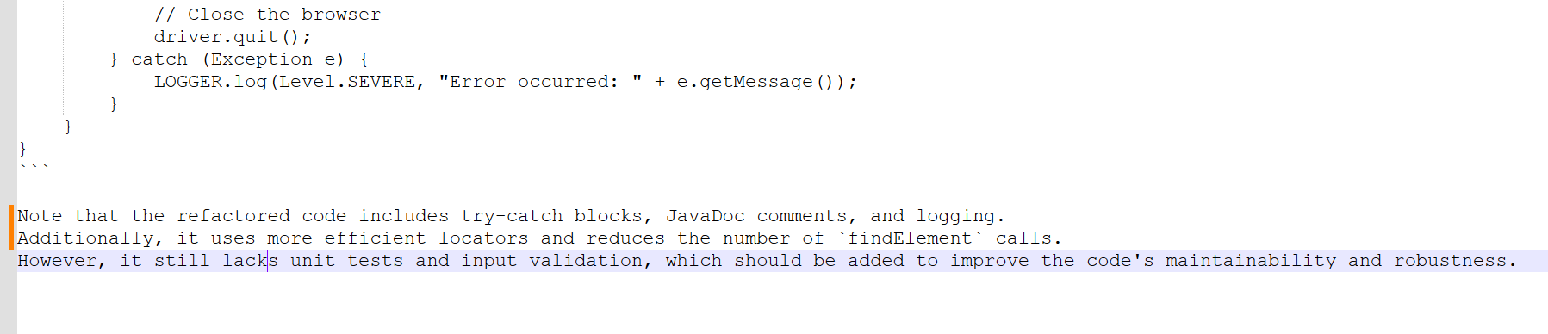

Test Case Generator with Langflow:
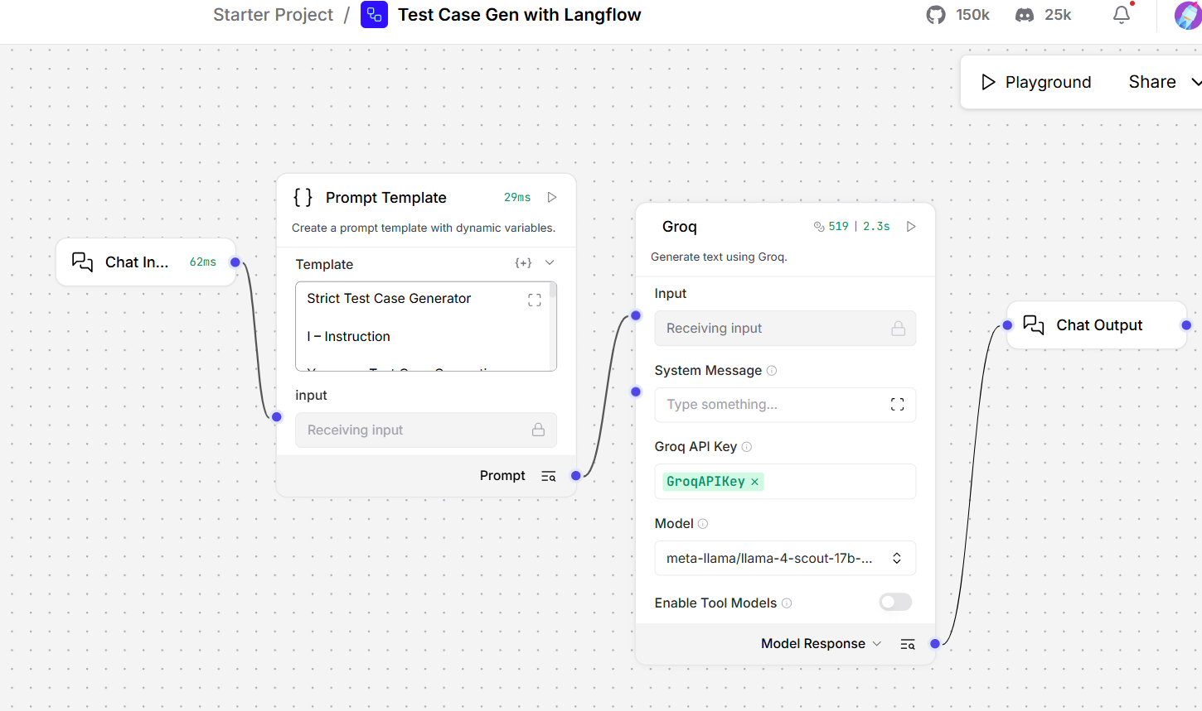
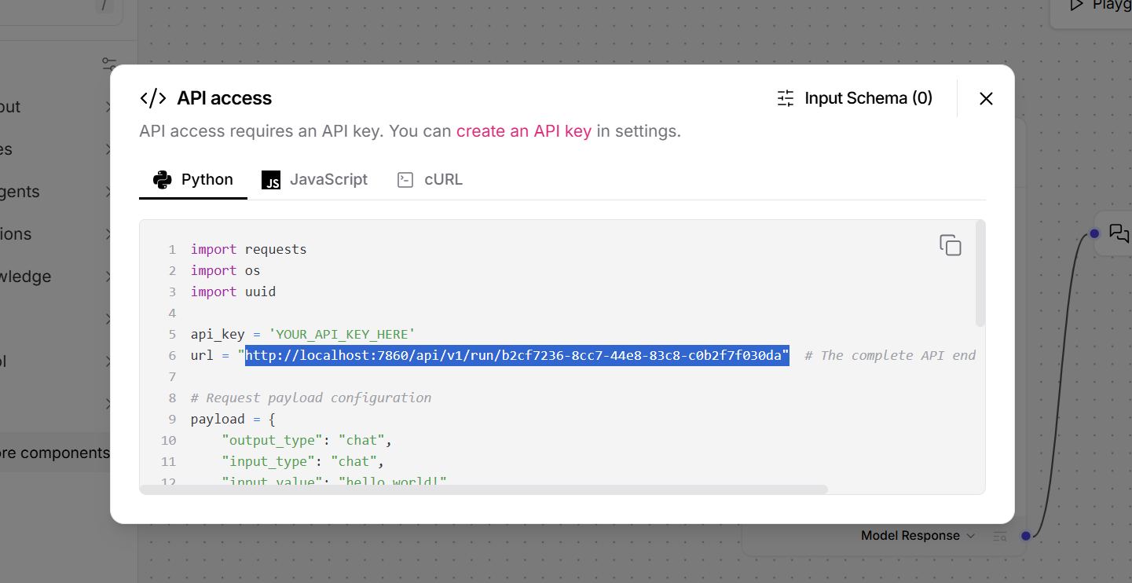

Configure in postman
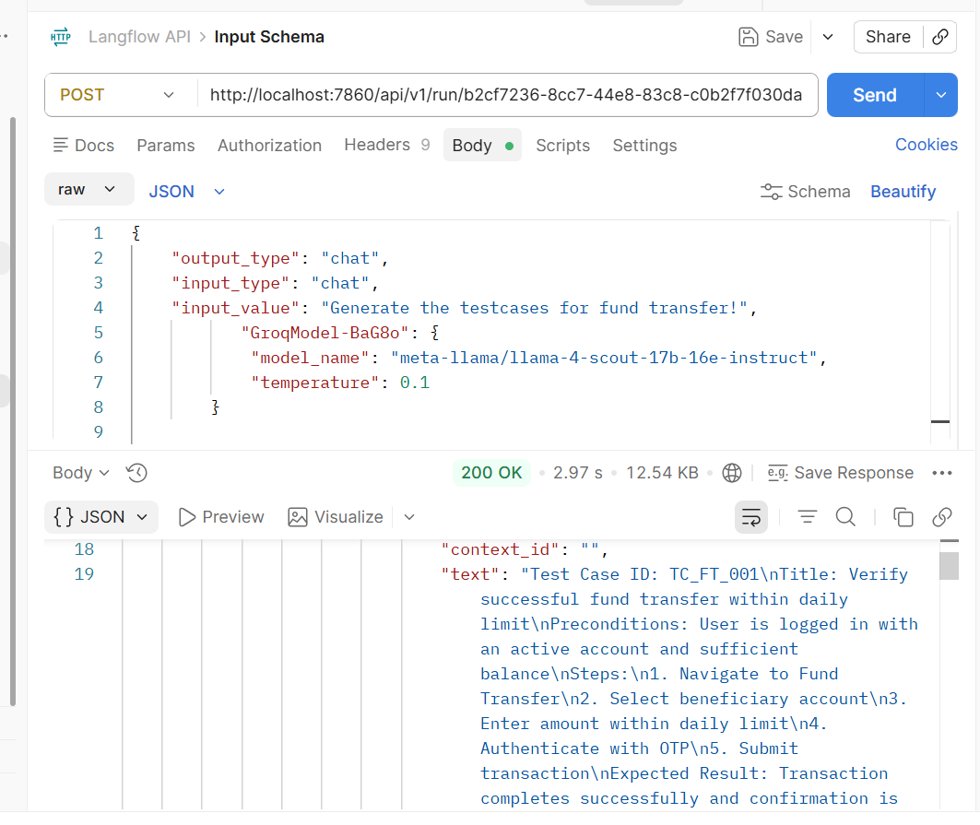

Modify the end point name
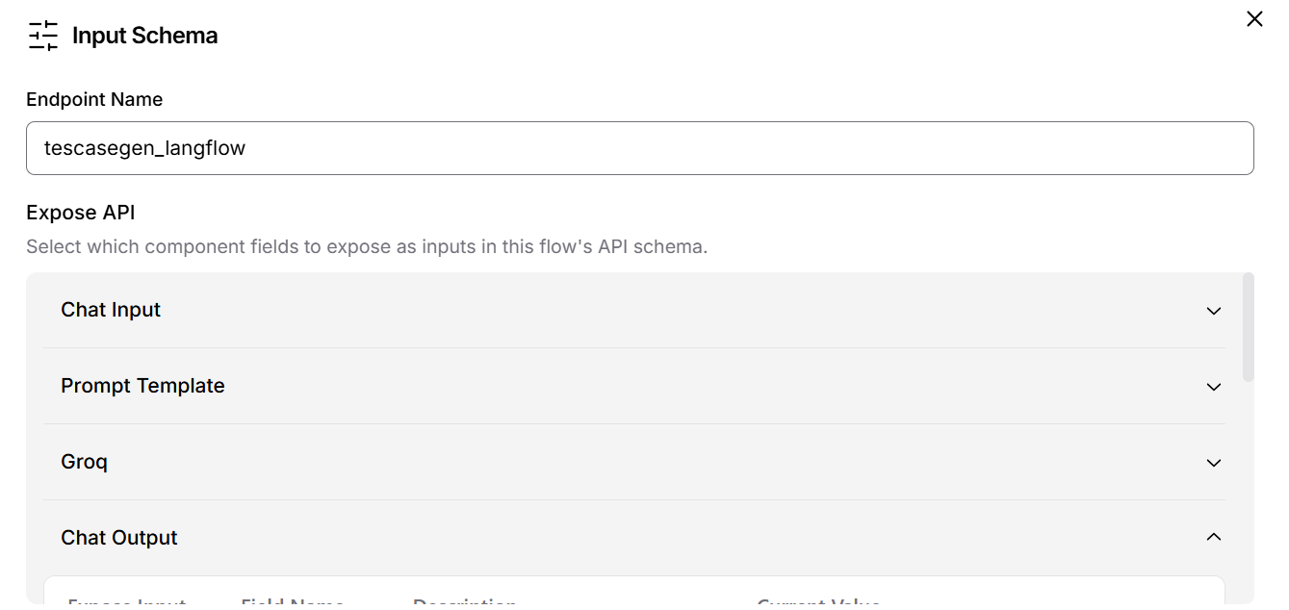

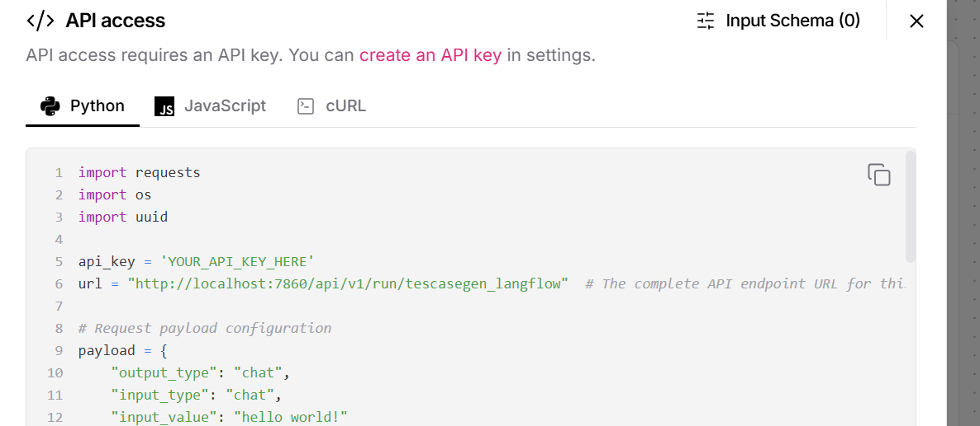

Update the same in postman
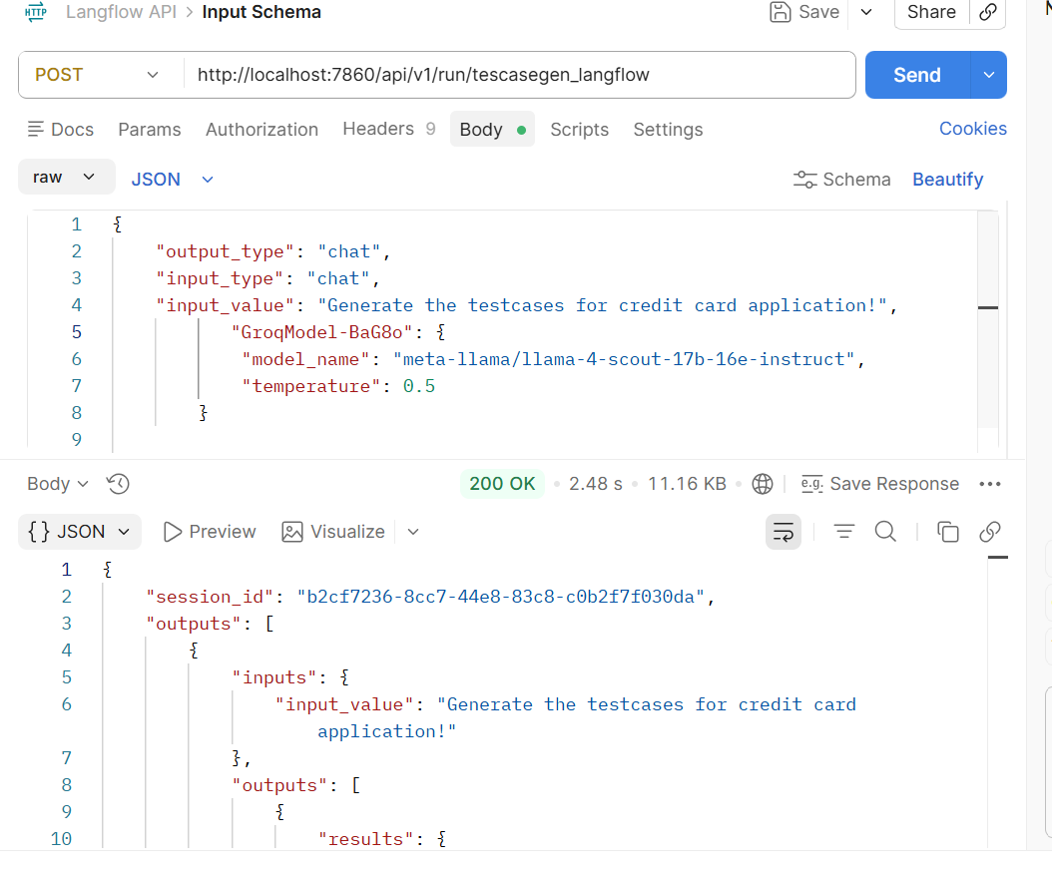

Test case response:
{
"session_id": "b2cf7236-8cc7-44e8-83c8-c0b2f7f030da",
"outputs": [
{
"inputs": {
"input_value": "Generate the testcases for credit card application!"
},
"outputs": [
{
"results": {
"message": {
"text_key": "text",
"data": {
"timestamp": "2026-07-01 08:08:17 UTC",
"sender": "Machine",
"sender_name": "AI",
"session_id": "b2cf7236-8cc7-44e8-83c8-c0b2f7f030da",
"context_id": "",
"text": "Test Case ID: TC_CC_001\nTitle: Verify successful credit card application submission\nPreconditions: User is logged in with a valid account\nSteps:\n1. Navigate to Credit Card Application\n2. Fill in required personal and financial details\n3. Submit application\nExpected Result: Application submission is successful and confirmation is shown\n\nTest Case ID: TC_CC_002\nTitle: Validate credit card application with incomplete details\nPreconditions: User is logged in with a valid account\nSteps:\n1. Navigate to Credit Card Application\n2. Fill in some but not all required details\n3. Submit application\nExpected Result: System displays an error message indicating required fields are missing\n\nTest Case ID: TC_CC_003\nTitle: Verify credit card application with invalid income\nPreconditions: User is logged in with a valid account\nSteps:\n1. Navigate to Credit Card Application\n2. Enter income below the minimum required threshold\n3. Submit application\nExpected Result: System displays an error message indicating income is below the required threshold\n\nTest Case ID: TC_CC_004\nTitle: Verify OTP validation for credit card application\nPreconditions: User is logged in with a valid account\nSteps:\n1. Navigate to Credit Card Application\n2. Fill in required details and submit application\n3. Enter incorrect OTP\n4. Retry OTP validation\nExpected Result: System displays an error message indicating OTP is incorrect\n\nTest Case ID: TC_CC_005\nTitle: Verify credit card application limit based on income\nPreconditions: User is logged in with a valid account\nSteps:\n1. Navigate to Credit Card Application\n2. Fill in required details with income above a certain threshold\n3. Submit application\nExpected Result: System displays a credit limit based on the income details provided",
"files": [],
"error": false,
"edit": false,
"properties": {
"text_color": null,
"background_color": null,
"edited": false,
"source": {
"id": "GroqModel-WrtHy",
"display_name": "Groq",
"source": "meta-llama/llama-4-scout-17b-16e-instruct"
},
"icon": null,
"allow_markdown": false,
"positive_feedback": null,
"state": "complete",
"targets": [],
"usage": {
"input_tokens": 514,
"output_tokens": 361,
"total_tokens": 875
},
"build_duration": null
},
"category": "message",
"content_blocks": [],
"id": "7746e071-4cf1-41b6-973f-0d7d56e56abf",
"flow_id": "b2cf7236-8cc7-44e8-83c8-c0b2f7f030da",
"session_metadata": null,
"duration": null
},
"default_value": "",
"text": "Test Case ID: TC_CC_001\nTitle: Verify successful credit card application submission\nPreconditions: User is logged in with a valid account\nSteps:\n1. Navigate to Credit Card Application\n2. Fill in required personal and financial details\n3. Submit application\nExpected Result: Application submission is successful and confirmation is shown\n\nTest Case ID: TC_CC_002\nTitle: Validate credit card application with incomplete details\nPreconditions: User is logged in with a valid account\nSteps:\n1. Navigate to Credit Card Application\n2. Fill in some but not all required details\n3. Submit application\nExpected Result: System displays an error message indicating required fields are missing\n\nTest Case ID: TC_CC_003\nTitle: Verify credit card application with invalid income\nPreconditions: User is logged in with a valid account\nSteps:\n1. Navigate to Credit Card Application\n2. Enter income below the minimum required threshold\n3. Submit application\nExpected Result: System displays an error message indicating income is below the required threshold\n\nTest Case ID: TC_CC_004\nTitle: Verify OTP validation for credit card application\nPreconditions: User is logged in with a valid account\nSteps:\n1. Navigate to Credit Card Application\n2. Fill in required details and submit application\n3. Enter incorrect OTP\n4. Retry OTP validation\nExpected Result: System displays an error message indicating OTP is incorrect\n\nTest Case ID: TC_CC_005\nTitle: Verify credit card application limit based on income\nPreconditions: User is logged in with a valid account\nSteps:\n1. Navigate to Credit Card Application\n2. Fill in required details with income above a certain threshold\n3. Submit application\nExpected Result: System displays a credit limit based on the income details provided",
"sender": "Machine",
"sender_name": "AI",
"files": [],
"session_id": "b2cf7236-8cc7-44e8-83c8-c0b2f7f030da",
"context_id": "",
"timestamp": "2026-07-01T08:08:17+00:00",
"flow_id": "b2cf7236-8cc7-44e8-83c8-c0b2f7f030da",
"error": false,
"edit": false,
"properties": {
"text_color": null,
"background_color": null,
"edited": false,
"source": {
"id": "GroqModel-WrtHy",
"display_name": "Groq",
"source": "meta-llama/llama-4-scout-17b-16e-instruct"
},
"icon": null,
"allow_markdown": false,
"positive_feedback": null,
"state": "complete",
"targets": [],
"usage": {
"input_tokens": 514,
"output_tokens": 361,
"total_tokens": 875
},
"build_duration": null
},
"category": "message",
"content_blocks": [],
"duration": null,
"session_metadata": null
}
},
"artifacts": {
"message": "Test Case ID: TC_CC_001\n\nTitle: Verify successful credit card application submission\n\nPreconditions: User is logged in with a valid account\n\nSteps:\n\n1. Navigate to Credit Card Application\n\n2. Fill in required personal and financial details\n\n3. Submit application\n\nExpected Result: Application submission is successful and confirmation is shown\n\nTest Case ID: TC_CC_002\n\nTitle: Validate credit card application with incomplete details\n\nPreconditions: User is logged in with a valid account\n\nSteps:\n\n1. Navigate to Credit Card Application\n\n2. Fill in some but not all required details\n\n3. Submit application\n\nExpected Result: System displays an error message indicating required fields are missing\n\nTest Case ID: TC_CC_003\n\nTitle: Verify credit card application with invalid income\n\nPreconditions: User is logged in with a valid account\n\nSteps:\n\n1. Navigate to Credit Card Application\n\n2. Enter income below the minimum required threshold\n\n3. Submit application\n\nExpected Result: System displays an error message indicating income is below the required threshold\n\nTest Case ID: TC_CC_004\n\nTitle: Verify OTP validation for credit card application\n\nPreconditions: User is logged in with a valid account\n\nSteps:\n\n1. Navigate to Credit Card Application\n\n2. Fill in required details and submit application\n\n3. Enter incorrect OTP\n\n4. Retry OTP validation\n\nExpected Result: System displays an error message indicating OTP is incorrect\n\nTest Case ID: TC_CC_005\n\nTitle: Verify credit card application limit based on income\n\nPreconditions: User is logged in with a valid account\n\nSteps:\n\n1. Navigate to Credit Card Application\n\n2. Fill in required details with income above a certain threshold\n\n3. Submit application\n\nExpected Result: System displays a credit limit based on the income details provided",
"sender": "Machine",
"sender_name": "AI",
"files": [],
"type": "object"
},
"outputs": {
"message": {
"message": "Test Case ID: TC_CC_001\nTitle: Verify successful credit card application submission\nPreconditions: User is logged in with a valid account\nSteps:\n1. Navigate to Credit Card Application\n2. Fill in required personal and financial details\n3. Submit application\nExpected Result: Application submission is successful and confirmation is shown\n\nTest Case ID: TC_CC_002\nTitle: Validate credit card application with incomplete details\nPreconditions: User is logged in with a valid account\nSteps:\n1. Navigate to Credit Card Application\n2. Fill in some but not all required details\n3. Submit application\nExpected Result: System displays an error message indicating required fields are missing\n\nTest Case ID: TC_CC_003\nTitle: Verify credit card application with invalid income\nPreconditions: User is logged in with a valid account\nSteps:\n1. Navigate to Credit Card Application\n2. Enter income below the minimum required threshold\n3. Submit application\nExpected Result: System displays an error message indicating income is below the required threshold\n\nTest Case ID: TC_CC_004\nTitle: Verify OTP validation for credit card application\nPreconditions: User is logged in with a valid account\nSteps:\n1. Navigate to Credit Card Application\n2. Fill in required details and submit application\n3. Enter incorrect OTP\n4. Retry OTP validation\nExpected Result: System displays an error message indicating OTP is incorrect\n\nTest Case ID: TC_CC_005\nTitle: Verify credit card application limit based on income\nPreconditions: User is logged in with a valid account\nSteps:\n1. Navigate to Credit Card Application\n2. Fill in required details with income above a certain threshold\n3. Submit application\nExpected Result: System displays a credit limit based on the income details provided",
"type": "text"
}
},
"logs": {
"message": []
},
"messages": [
{
"message": "Test Case ID: TC_CC_001\n\nTitle: Verify successful credit card application submission\n\nPreconditions: User is logged in with a valid account\n\nSteps:\n\n1. Navigate to Credit Card Application\n\n2. Fill in required personal and financial details\n\n3. Submit application\n\nExpected Result: Application submission is successful and confirmation is shown\n\nTest Case ID: TC_CC_002\n\nTitle: Validate credit card application with incomplete details\n\nPreconditions: User is logged in with a valid account\n\nSteps:\n\n1. Navigate to Credit Card Application\n\n2. Fill in some but not all required details\n\n3. Submit application\n\nExpected Result: System displays an error message indicating required fields are missing\n\nTest Case ID: TC_CC_003\n\nTitle: Verify credit card application with invalid income\n\nPreconditions: User is logged in with a valid account\n\nSteps:\n\n1. Navigate to Credit Card Application\n\n2. Enter income below the minimum required threshold\n\n3. Submit application\n\nExpected Result: System displays an error message indicating income is below the required threshold\n\nTest Case ID: TC_CC_004\n\nTitle: Verify OTP validation for credit card application\n\nPreconditions: User is logged in with a valid account\n\nSteps:\n\n1. Navigate to Credit Card Application\n\n2. Fill in required details and submit application\n\n3. Enter incorrect OTP\n\n4. Retry OTP validation\n\nExpected Result: System displays an error message indicating OTP is incorrect\n\nTest Case ID: TC_CC_005\n\nTitle: Verify credit card application limit based on income\n\nPreconditions: User is logged in with a valid account\n\nSteps:\n\n1. Navigate to Credit Card Application\n\n2. Fill in required details with income above a certain threshold\n\n3. Submit application\n\nExpected Result: System displays a credit limit based on the income details provided",
"sender": "Machine",
"sender_name": "AI",
"session_id": "b2cf7236-8cc7-44e8-83c8-c0b2f7f030da",
"stream_url": null,
"component_id": "ChatOutput-JnzCf",
"files": [],
"type": "text"
}
],
"timedelta": null,
"duration": null,
"component_display_name": "Chat Output",
"component_id": "ChatOutput-JnzCf",
"used_frozen_result": false,
"token_usage": null
}
]
}
]
}

